Network Security Audit Lab
Phase 3 – Network Reconnaissance & Vulnerability Assessment
Prepared By: Sarrah Amini
Tools Used: Kali Linux, Metasploitable 2, Nmap, Wireshark

TABLE OF CONTENTS:
1. Executive Summary
1.1 Scope of Work
1.2 Assessment Objective
2. Environment Setup
2.1 Lab Environment
2.2 Network Configuration
2.3 Tools Used
3. Methodology
3.1 Host Discovery
3.2 Service & Version Detection
3.3 Operating System Detection
3.4 Aggressive Scan
3.5 Full TCP Port Scan
3.6 Packet Capture Using Wireshark
3.7 Network Traffic Analysis
4. Detailed Findings
4.1 Open TCP Ports Identified
4.2 Services & Versions Detected
4.3 Operating System Identification
4.4 Full Port Scan Results
4.5 Wireshark Packet Analysis
4.6 Security Observations
5. Recommendations / Best Practices
5.1 Reduce Unnecessary Open Ports
5.2 Secure and Update Network Services
5.3 Replace Insecure Legacy Services
5.4 Restrict Access to Network Services
5.5 Secure File Sharing and Database Services
5.6 Monitor and Analyze Network Traffic
5.7 Conduct Regular Security Assessments
5.8 Overall Recommendation
6. Conclusion
7. References

1. Executive Summary
1.1 Scope of Work
This phase focused on conducting network reconnaissance against a deliberately vulnerable Linux system within a controlled virtual lab environment. The assessment was performed using Kali Linux as the attacking machine and Metasploitable 2 as the target host. The activities included identifying active network services, detecting service versions, performing operating system fingerprinting, scanning the complete TCP port range, and analyzing the generated network traffic using Wireshark. All testing was carried out in an isolated environment for educational purposes without impacting any production systems.

1.2 Assessment Objective
The primary objective of this assessment was to understand the reconnaissance phase of a cybersecurity assessment by identifying exposed network services and collecting information about the target system. Nmap was used to perform host discovery, service enumeration, operating system detection, and comprehensive TCP port scanning. Additionally, Wireshark was used to capture and analyze the network packets generated during the scans to understand how reconnaissance activities appear at the packet level. The knowledge gained from this phase provides a foundation for identifying potential attack surfaces while also improving the ability to recognize reconnaissance activity from a defensive perspective.

2. Environment Setup
2.1 Lab Environment
The assessment was conducted in an isolated virtual laboratory environment created using Oracle VirtualBox. The lab was designed to simulate an attacker and target system while ensuring that all reconnaissance and network security testing could be performed safely without affecting production systems.
The environment consisted of two virtual machines:
System | Role | IP Address
Kali Linux | Security Assessment / Attacker Machine | 192.168.1.3
Metasploitable 2 | Vulnerable Target Machine | 192.168.1.4

Kali Linux was used as the primary security assessment machine. It provided the tools required to perform network reconnaissance, port scanning, service enumeration, and packet analysis.
Metasploitable 2 was deployed as the target system. It is an intentionally vulnerable Linux virtual machine containing multiple outdated and insecure services, making it suitable for controlled cybersecurity training and security assessment exercises.
Both virtual machines were hosted in Oracle VirtualBox and connected to the same isolated NAT Network named hacking_lab, allowing communication between the assessment machine and the target.
Figure 2.1.1: VirtualBox lab environment containing Kali Linux and Metasploitable 2
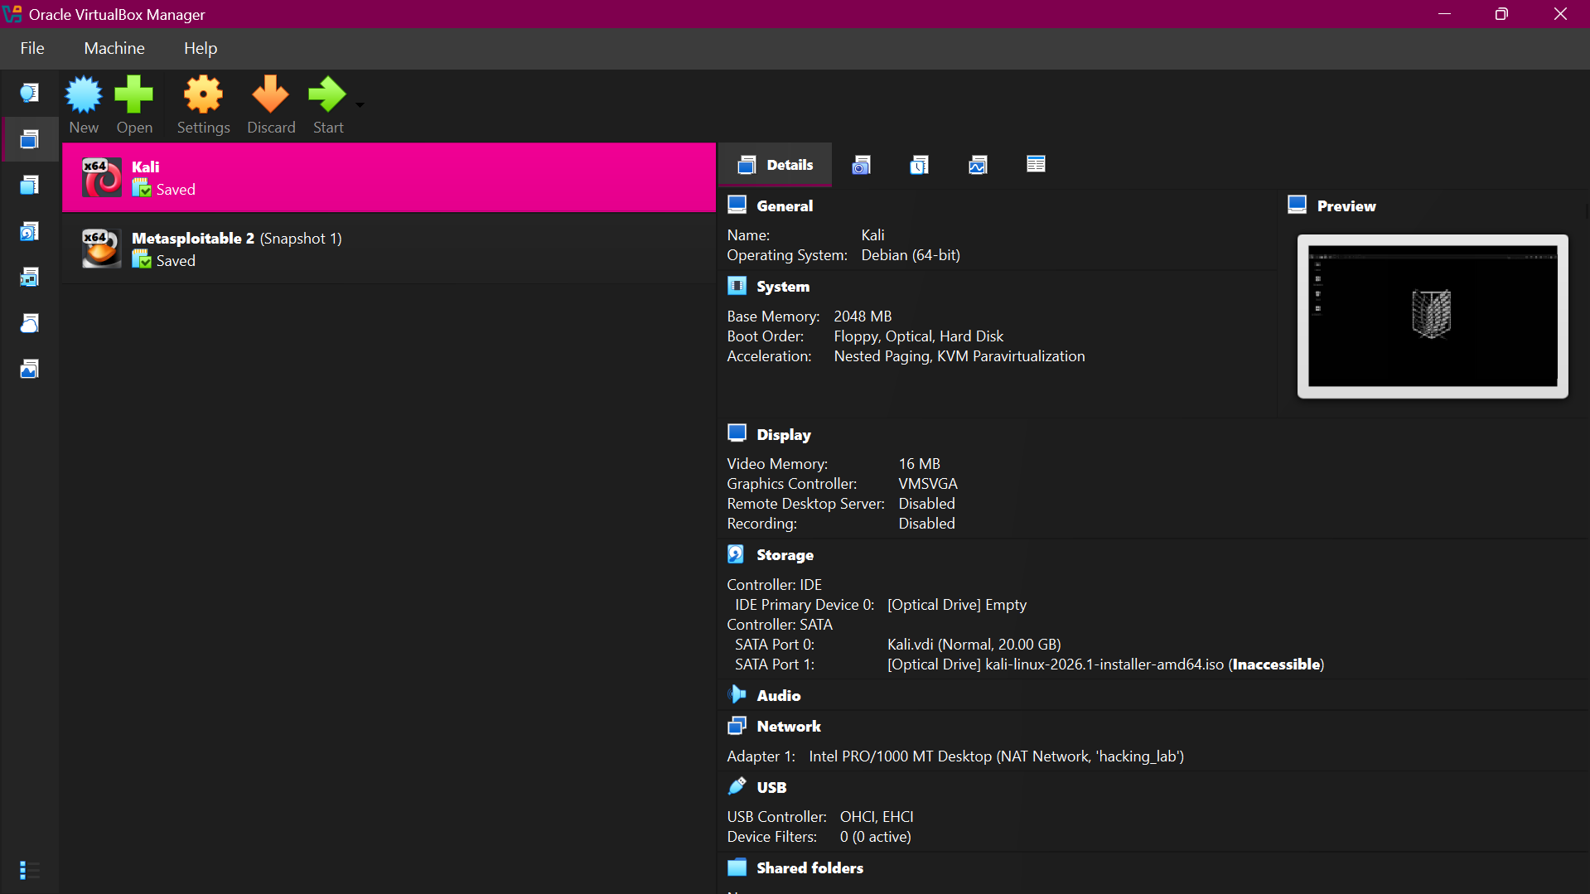

2.2 Network Configuration
The virtual machines were connected through an isolated NAT Network named hacking_lab in Oracle VirtualBox. This network allowed the Kali Linux assessment machine and the Metasploitable 2 target machine to communicate with each other within the controlled laboratory environment.
The network was configured using the 192.168.1.0/24 address range. Kali Linux was assigned the IP address 192.168.1.3, while Metasploitable 2 was assigned 192.168.1.4.
Figure 2.2.1: Kali Linux IP configuration showing 192.168.1.3
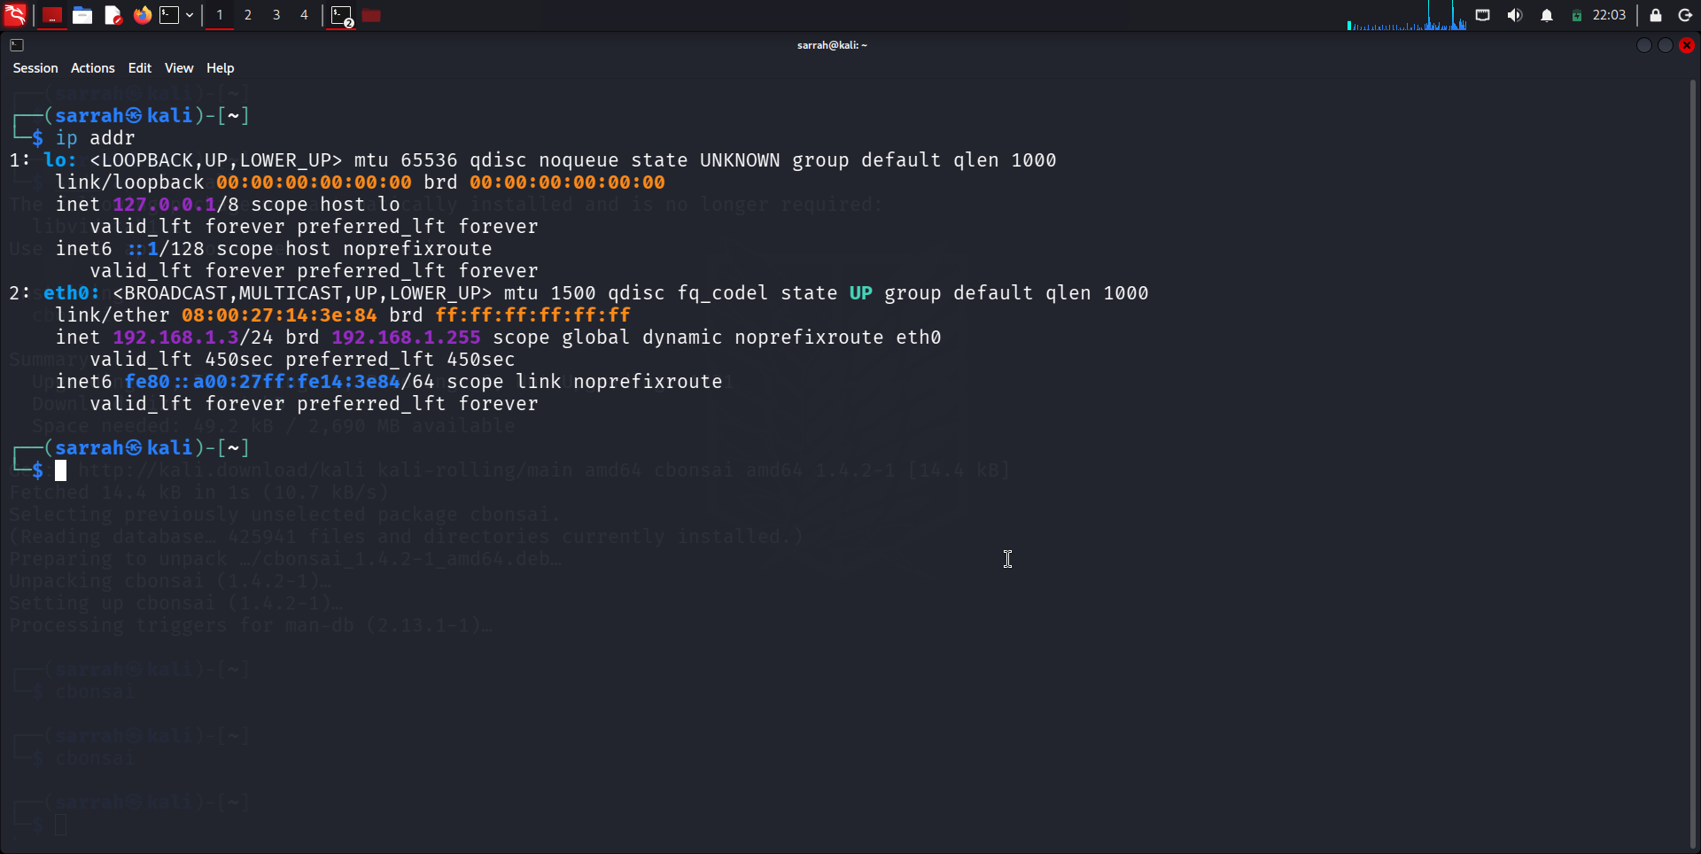

Figure 2.2.2: Metasploitable 2 IP configuration showing 192.168.1.4
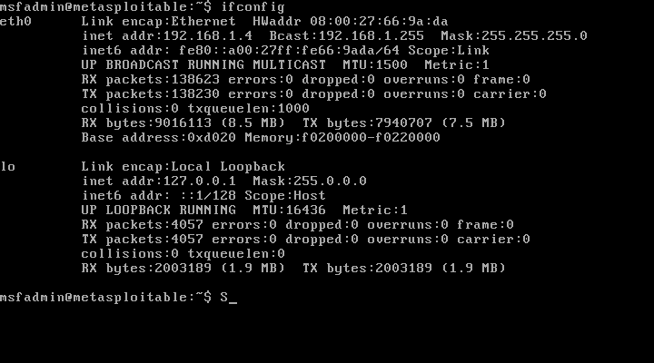

Figure 2.2.3: Connectivity test from Kali Linux to Metasploitable 2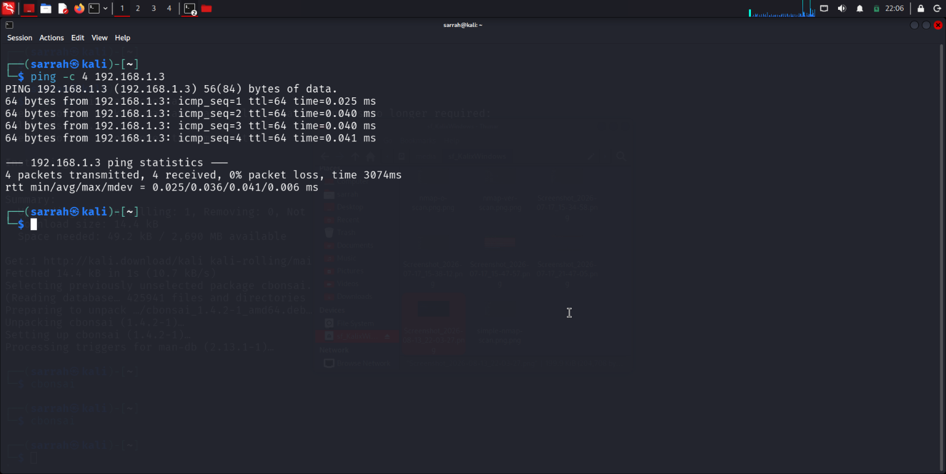

2.3 Tools Used
The following tools were used during the assessment to establish the virtual laboratory, perform network reconnaissance, and analyze the resulting network traffic.
Tool | Purpose
Oracle VirtualBox | Used to create and manage the isolated virtual laboratory environment containing Kali Linux and Metasploitable 2.
Kali Linux | Used as the security assessment machine for conducting reconnaissance and network analysis.
Metasploitable 2 | Used as the intentionally vulnerable target system for controlled security testing.
Nmap | Used for host discovery, port scanning, service and version detection, OS detection, and reconnaissance.
Wireshark | Used to capture and analyze the network traffic generated during Nmap scanning.

3. Methodology
Introduction
The methodology followed a structured network reconnaissance and traffic analysis process. The assessment began with basic host and port discovery and progressively moved toward service enumeration, operating system detection, comprehensive TCP port scanning, and packet-level analysis. Nmap was used as the primary reconnaissance tool, while Wireshark was used to examine the network traffic generated during the scanning process.
3.1 Initial Host Discovery and Port Scanning
Objective
The initial scan was performed to determine whether the target system was reachable and to identify commonly used TCP ports that were accessible on the host.
Command Used: nmap 192.168.1.4
Description
Nmap was used to perform a basic scan against the Metasploitable 2 target. The scan examined commonly used TCP ports and identified ports that were in an open state. This provided an initial overview of the services exposed by the target and established a baseline for subsequent reconnaissance activities.
Result
The scan successfully identified the Metasploitable 2 host and revealed multiple open TCP ports. These results were used as the basis for further service and version enumeration.
Figure 3.1.1: Basic nmap scan of the Metasploitable 2 target
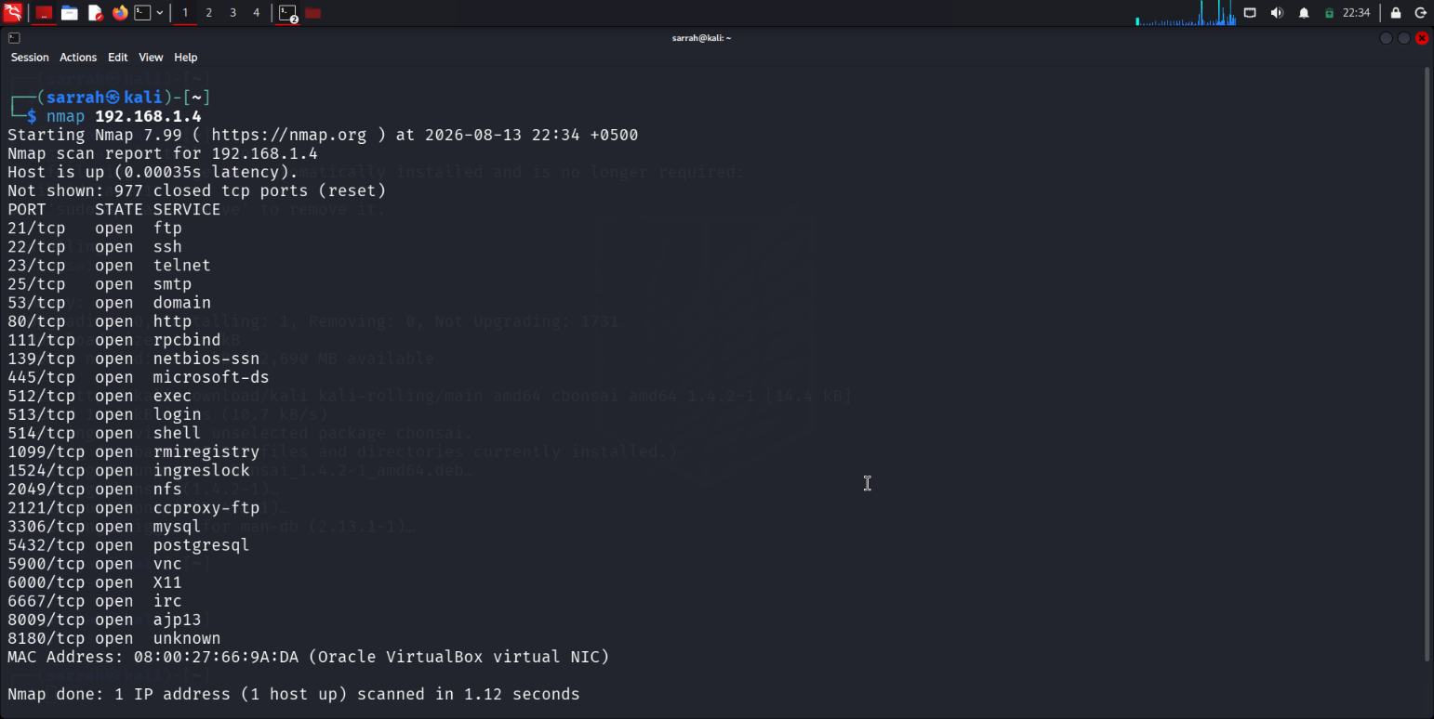
3.2 Service & Version Detection
Objective
To identify the services running on the open ports of the target system and determine their corresponding software versions.
Command Used: nmap -sV 192.168.1.4
Description
The -sV option enables Nmap's service and version detection. It probes the identified open ports to determine the services running on them and, where possible, the specific software versions.
Result
The scan successfully identified multiple services running on the target system and provided version information for the detected services. The results were recorded for further analysis in the Detailed Findings section.
Figure 3.2.1: nmap Service and Version Detection Results
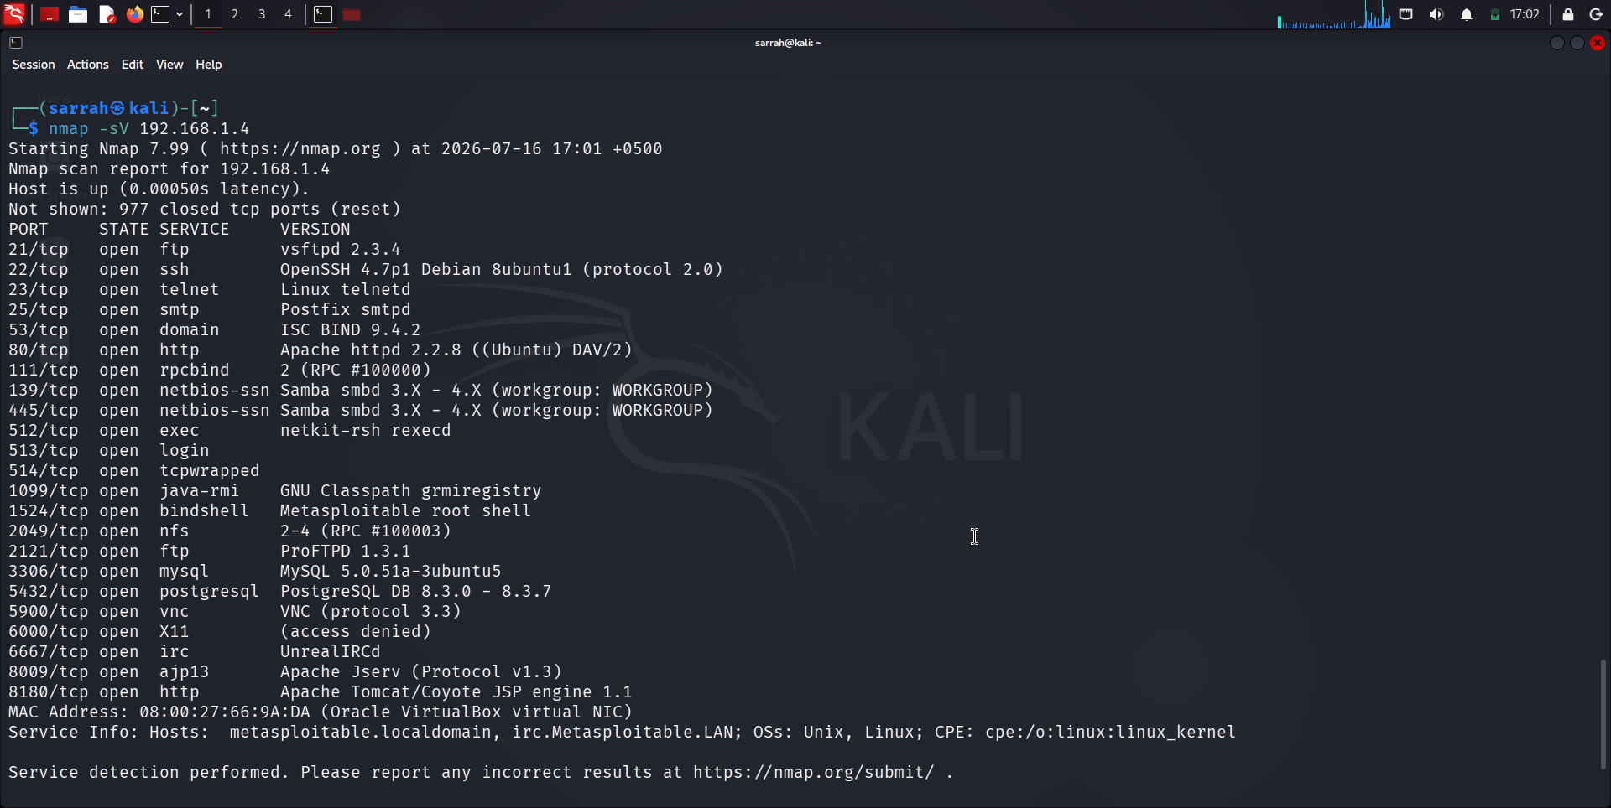

3.3 Operating System Detection
Objective
To identify the operating system and underlying system characteristics of the target host.
Command Used: sudo nmap -O 192.168.1.4
Description
The -O option enables Nmap's operating system detection feature. Nmap analyzes network responses from the target to determine the most likely operating system and related system characteristics.
Result
The scan was used to identify the operating system running on the Metasploitable 2 target. The results provided information about the target's operating system and helped establish the underlying platform for further security assessment.
Figure 3.3.1: nmap Operating System Detection Results
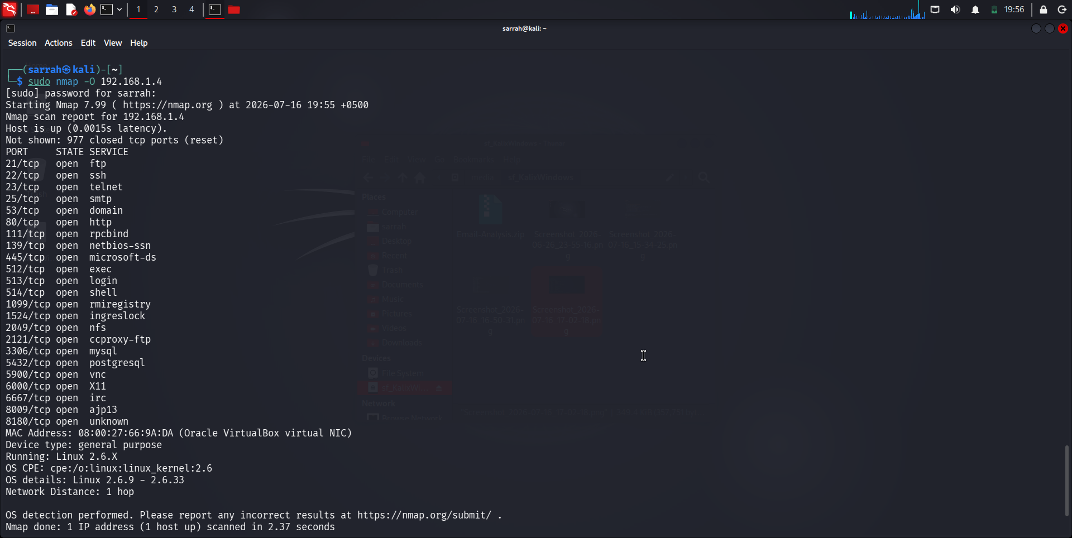

3.4 Aggressive Scan
Objective
To perform a comprehensive scan of the target system and gather detailed information about its services, operating system, network characteristics, and potential security weaknesses.
Command Used: sudo nmap -A 192.168.1.4
Description
The -A option enables Nmap's aggressive scan mode. It combines several scanning and detection techniques, including operating system detection, service/version detection, script scanning, and traceroute, to provide more detailed information about the target host.
Result
The aggressive scan provided detailed information about the target system, including detected services, service versions, operating system information, and other network characteristics. This gave a broader view of the target's exposed services and potential security-relevant information.
Figure 3.4.1: nmap Aggressive Scan Results
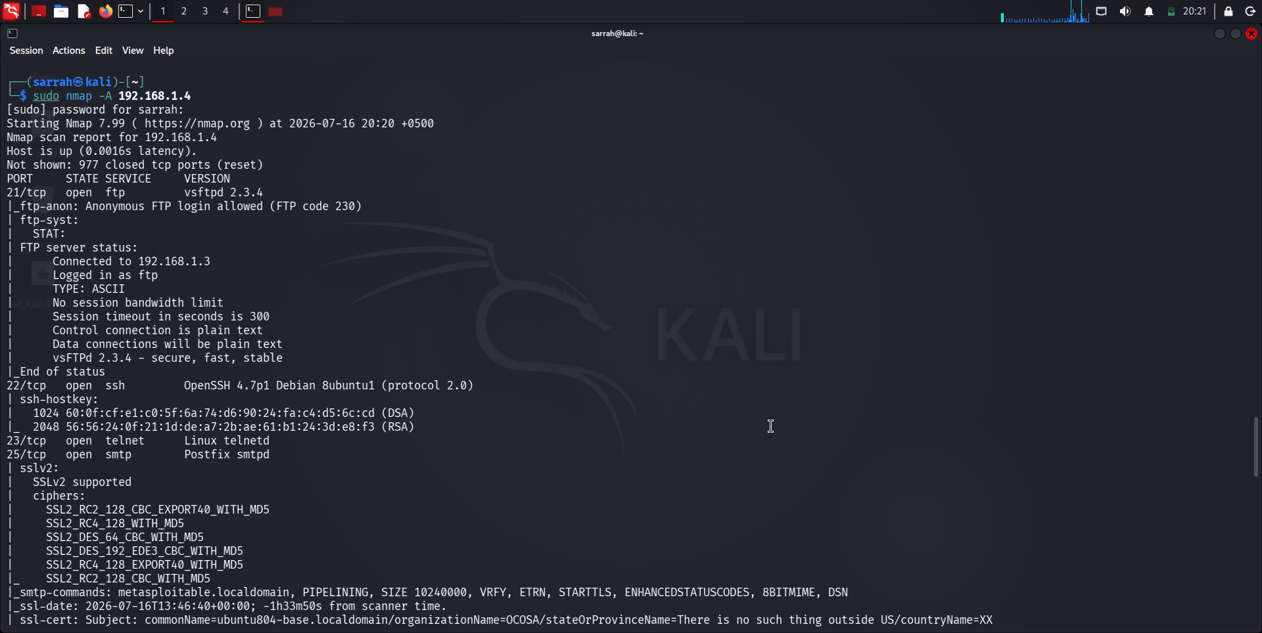
3.5 Full TCP Port Scan
Objective
To scan all 65,535 TCP ports on the target system and identify any open TCP ports that may not be detected during a scan of commonly used ports.
Command Used: sudo nmap -p- 192.168.1.4
Description
The -p- option instructs Nmap to scan the complete TCP port range from 1 through 65,535. This provides a more comprehensive assessment of the target's exposed TCP services compared with scanning only selected or commonly used ports.
Result
The scan identified multiple open TCP ports across the full port range. The results were used for further analysis of the target's exposed services and attack surface.
Figure 3.5.1: Nmap Full TCP Port Scan Results
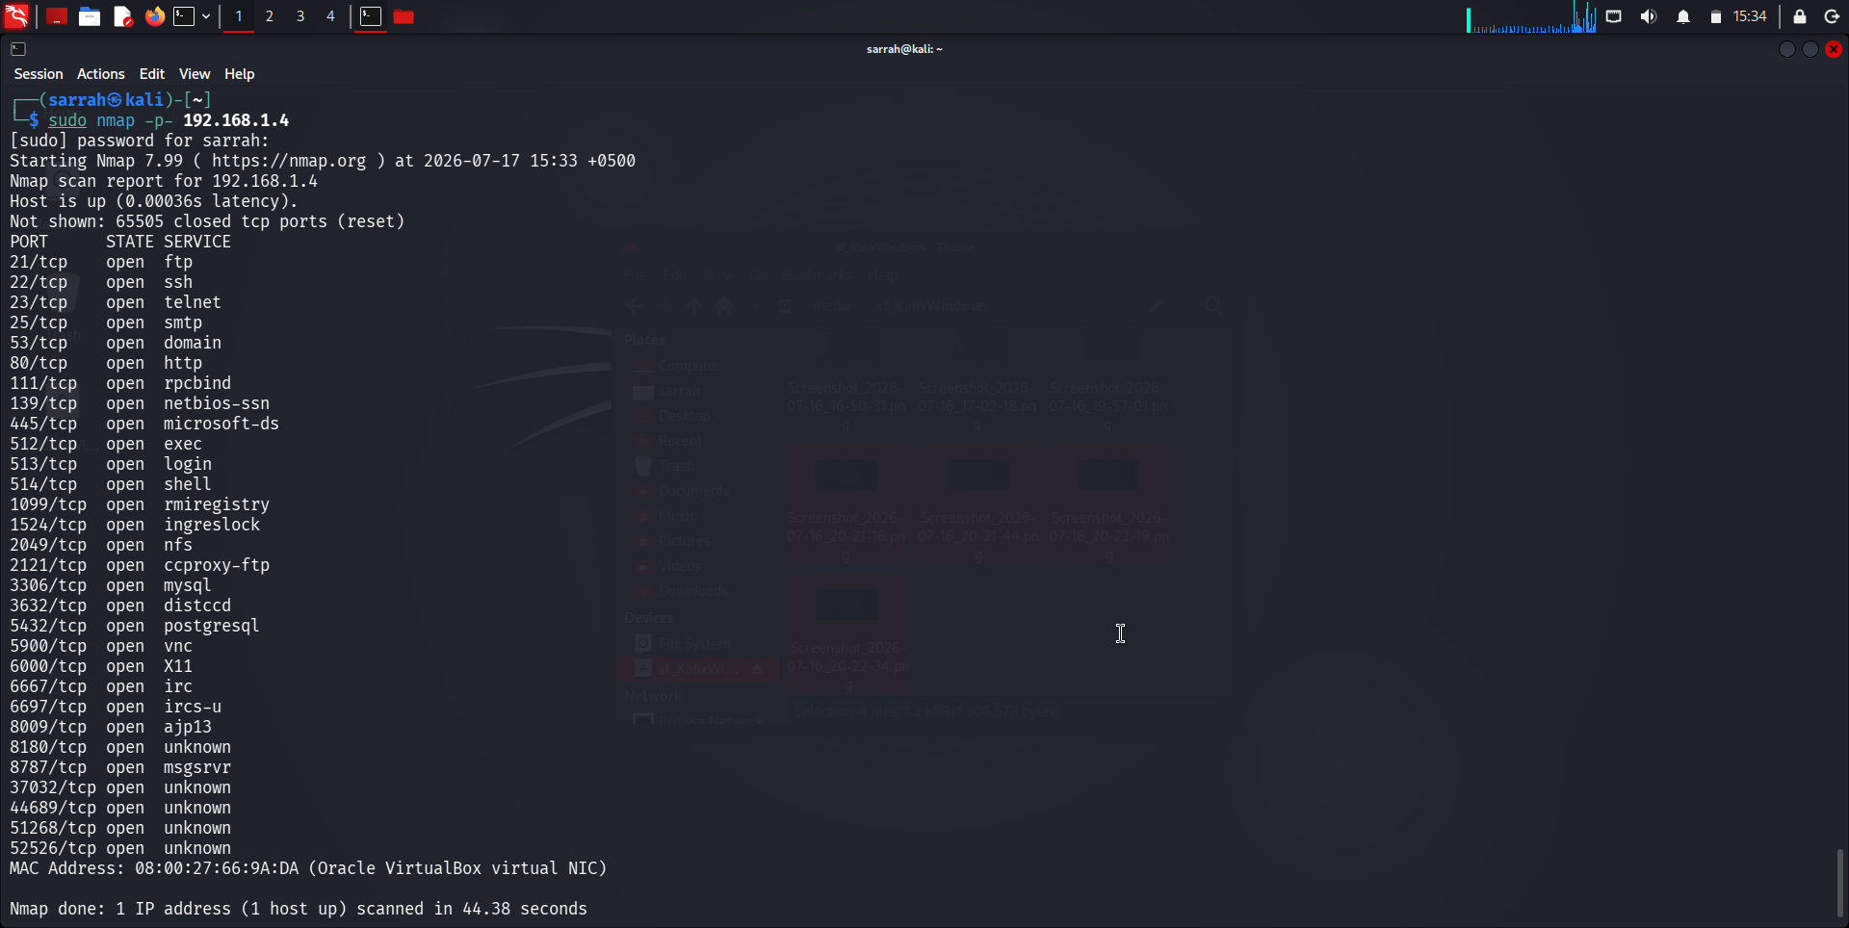

3.6 Packet Capture Using Wireshark
Objective
To capture and examine the network traffic generated during the Nmap scanning process in order to observe the communication between the Kali Linux assessment machine and the Metasploitable 2 target.
Command Used: sudo nmap -sS 192.168.1.4
Description
Wireshark was used to capture network packets exchanged between Kali Linux (192.168.1.3) and Metasploitable 2 (192.168.1.4) while an Nmap SYN scan was being performed. A Wireshark display filter was used to focus the capture on traffic involving the target system. The captured packets included TCP SYN requests and responses generated during the scanning process.
Result
The packet capture successfully recorded the traffic generated by the Nmap scan. The captured packets provided visibility into the TCP connection attempts made by Nmap and the responses returned by the target. The capture was subsequently used for detailed packet-level analysis.
Figure 3.6.1: Wireshark packet capture of Nmap scanning traffic
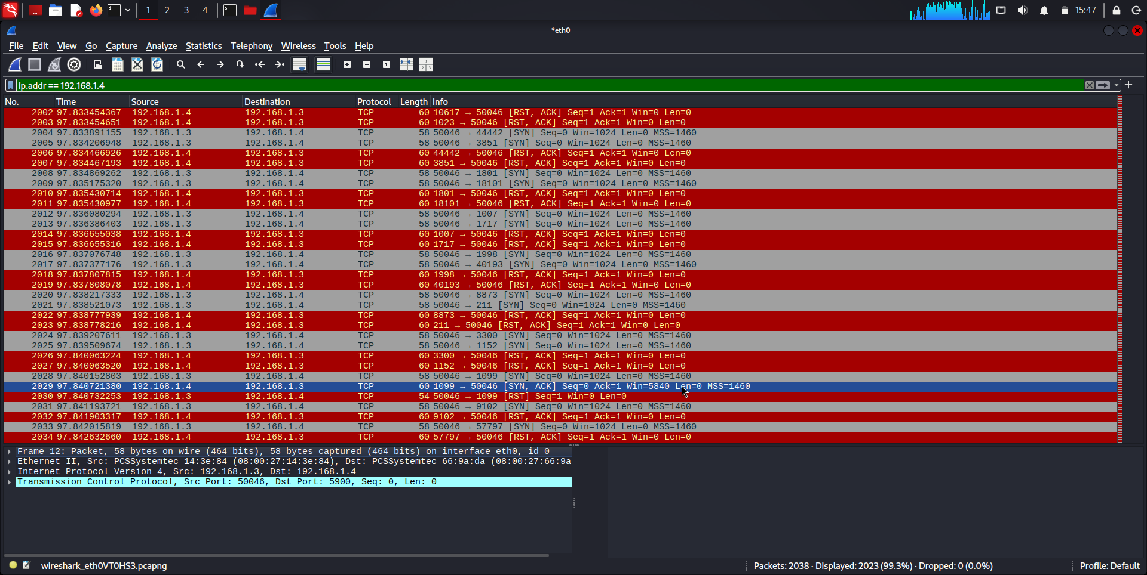

4. Detailed Findings
4.1 Open TCP Ports Identified
Finding
The full TCP port scan identified 30 open TCP ports on the Metasploitable 2 host (192.168.1.4). The open ports expose a wide range of network services, including remote access, file sharing, web, database, and other application services.
Port | Service | Port | Service | Port | Service | Port | Service
21 | FTP | 445 | Microsoft-DS | 3306 | MySQL | 8009 | AJP13
22 | SSH | 512 | exec | 3632 | distccd | 8180 | HTTP
23 | Telnet | 513 | login | 5432 | PostgreSQL | 8787 | msgsrvr
25 | SMTP | 514 | shell | 5900 | VNC | 139 | NetBIOS-SSN
53 | DNS | 1099 | rmiregistry | 6000 | X11 | 2121 | ccproxy-ftp
80 | HTTP | 1524 | ingreslock | 6667 | IRC | 51268 | Unknown
111 | RPCbind | 2049 | NFS | 6697 | IRCs-u | 52526 | Unknown

Analysis
The large number of open TCP ports indicates that the target exposes a broad network attack surface. Several ports provide remote access or access to network services, while others correspond to database, file-sharing, web, and application services. The presence of multiple unknown services also indicates areas requiring further investigation.

4.2 Services & Version Detection
The service and version detection scan identified multiple services running on the target host and provided information about the software versions associated with several open ports.
Port | Service | Version / Software
21/tcp | FTP | vsftpd 2.3.4
22/tcp | SSH | OpenSSH 4.7p1 Debian 8ubuntu1
23/tcp | Telnet | Linux telnetd
25/tcp | SMTP | Postfix smtpd
53/tcp | DNS | ISC BIND 9.4.2
80/tcp | HTTP | Apache httpd 2.2.8
111/tcp | RPCbind | RPC #100000
139/tcp | NetBIOS-SSN | Samba smbd 3.X–4.X
445/tcp | Microsoft-DS | Samba smbd 3.X–4.X
512/tcp | exec | netkit-rsh rexecd
513/tcp | login | rlogin
514/tcp | tcpwrapped | —
1099/tcp | Java RMI | GNU Classpath rmiregistry
1524/tcp | bindshell | Metasploitable root shell
2049/tcp | NFS | RPC #100003
2121/tcp | FTP | ProFTPD 1.3.1
3306/tcp | MySQL | MySQL 5.0.51a-3ubuntu5
5432/tcp | PostgreSQL | PostgreSQL 8.3.0–8.3.7
5900/tcp | VNC | VNC protocol 3.3
6000/tcp | X11 | Access denied
6667/tcp | IRC | UnrealIRCd
8009/tcp | AJP13 | Apache Jserv
8180/tcp | HTTP | Apache Tomcat/Coyote JSP engine 1.1

Analysis
The scan revealed a wide variety of services and several outdated software versions running on the target. In particular, services such as FTP, Telnet, SMB, databases, VNC, and multiple web-related services increase the potential attack surface. The identified software versions can be further assessed for known vulnerabilities during the security assessment.

4.3 Operating System Identification
The operating system detection scan identified the target host as a Linux-based system. Nmap provided the following operating system information:
Finding | Result
Device Type | General purpose
Operating System | Linux 2.6.x
OS Details | Linux 2.6.9 – 2.6.33
Network Distance | 1 hop
Analysis
The results indicate that the Metasploitable 2 host is running an older Linux 2.6.x kernel. This is significant from a security perspective because outdated operating systems may contain known vulnerabilities and lack modern security protections.
The identified operating system also provides useful context for interpreting the vulnerable and outdated services discovered during the assessment.

4.4 Full Port Scan Results
The full TCP port scan examined all 65,535 TCP ports on the Metasploitable 2 host and identified 30 open TCP ports. In addition to the commonly detected ports, the scan revealed several additional open ports that were not identified during the initial scan.
Additional Ports Identified
Port | Service
3632/tcp | distccd
6697/tcp | ircs-u
8787/tcp | msgsrvr
37032/tcp | Unknown
44689/tcp | Unknown
51268/tcp | Unknown
52526/tcp | Unknown
Analysis
The full port scan revealed a broader attack surface than the initial scan of commonly used ports. Several additional services were identified, including distccd, IRC-related services, and multiple ports whose services could not be determined by the scan.
The presence of these additional and unidentified listening ports demonstrates the importance of scanning the complete TCP port range during a network security assessment, as services running on non-standard ports may otherwise remain undetected.

4.5 Wireshark Packet Analysis
The captured traffic was analyzed to observe the TCP communication generated during the Nmap SYN scan between the Kali Linux system (192.168.1.3) and the Metasploitable 2 target (192.168.1.4).
The capture shows repeated TCP SYN packets originating from Kali and directed toward different destination ports on the target. These packets represent connection attempts generated during the port scanning process.
The target responded to several of these probes with TCP RST, ACK packets, indicating that the corresponding ports were not accepting connections. The capture also shows RST, ACK responses from the target, indicating that corresponding connection attempts were rejected.
Key Observations
- Source: Kali Linux — 192.168.1.3
- Destination: Metasploitable 2 — 192.168.1.4
- Protocol: TCP
- Observed packets: TCP SYN and RST, ACK
- Purpose of SYN packets: Probe TCP ports to determine their state.
- RST, ACK responses: Indicate that the probed port rejected the connection attempt, consistent with a closed port.
- The capture demonstrates how Nmap's port-scanning activity appears at the packet level.
Overall, the Wireshark analysis provided packet-level evidence of the TCP probing performed during the Nmap scan and helped correlate the scanner's activity with the responses generated by the target.

4.6 Security Observations
The network assessment identified several security concerns on the Metasploitable 2 target. The following observations were derived from the Nmap scanning and Wireshark analysis:
- Large number of exposed TCP ports: The full TCP scan identified 30 open TCP ports, indicating a broad attack surface with numerous network-accessible services.
- Multiple network services exposed: Services including FTP, Telnet, SSH, HTTP, SMB, database services, VNC, and others were accessible from the assessment machine. The presence of numerous services increases the number of potential entry points into the system.
- Legacy and potentially insecure services: Services such as Telnet and older software versions were detected. Such services may introduce additional security risks, particularly when stronger or more secure alternatives are available.
- Unidentified services: Several open ports returned as unknown during the full port scan. These services require further investigation to determine their purpose and whether they should remain accessible.
- Potential for Unencrypted Communication: The assessment identified services such as Telnet and FTP that may transmit credentials or data without modern encryption when used in their traditional configurations. These services should therefore be replaced or secured where possible.
- Extensive attack surface: The combination of numerous open ports, multiple exposed services, and legacy software indicates that the target has a relatively large attack surface and would require appropriate service hardening and access controls.
Overall Observation
The assessment indicates that the target system has significant exposure at the network and service level. Reducing unnecessary open ports, disabling legacy or unnecessary services, updating outdated software, and restricting network access would help reduce the overall attack surface.

5. Recommendations / Best Practices
5.1 Reduce Unnecessary Open Ports
The assessment identified a large number of open TCP ports on the target system. Unnecessary services and ports should be disabled to reduce the system's overall attack surface.
Recommended practices:
- Disable services that are not required.
- Close unnecessary TCP ports.
- Restrict access to required services using firewall rules.
- Regularly review exposed ports and listening services.
5.2 Secure and Update Network Services
Several services and older software versions were identified during service and version detection. Outdated software may contain known security weaknesses and should be maintained through regular patching and updates.
Recommended practices:
- Keep operating systems and network services updated.
- Replace unsupported or obsolete software.
- Regularly check installed service versions against vendor security advisories.
- Remove software that is no longer required.
5.3 Replace Insecure Legacy Services
The assessment identified services such as Telnet and FTP. Where possible, insecure or plaintext protocols should be replaced with secure alternatives.
Recommended practices:
- Replace Telnet with SSH for remote administration.
- Prefer SFTP/FTPS over unencrypted FTP where appropriate.
- Use encrypted protocols to protect authentication credentials and transmitted data.
- Disable legacy protocols when they are no longer required.
5.4 Restrict Access to Network Services
Services should not be accessible to every system on the network unless there is a legitimate business requirement.
Recommended practices:
- Apply firewall rules based on source, destination, port, and protocol.
- Use network segmentation to isolate sensitive services.
- Restrict administrative services to authorized systems or management networks.
- Follow the principle of least privilege when granting network access.
5.5 Secure File Sharing and Database Services
Services such as SMB, MySQL, and PostgreSQL were identified during the assessment. These services should be restricted and securely configured because unauthorized access could expose sensitive information.
Recommended practices:
- Restrict database access to trusted hosts.
- Use strong authentication and unique credentials.
- Disable unnecessary database accounts and services.
- Secure SMB configurations and restrict unnecessary file shares.
- Avoid exposing database and file-sharing services directly to untrusted networks.
5.6 Monitor and Analyze Network Traffic
The Wireshark analysis demonstrated that network scanning activity can be observed through TCP connection attempts and responses. Network monitoring can therefore help identify reconnaissance and suspicious activity.
Recommended practices:
- Monitor unusual connection attempts and port-scanning activity.
- Use IDS/IPS solutions where appropriate.
- Maintain centralized security logs.
- Investigate repeated connection attempts against multiple ports.
- Establish baseline network traffic patterns to help identify anomalies.
5.7 Conduct Regular Security Assessments
A single security assessment provides only a snapshot of the system's security posture. Regular assessments should be performed to identify newly exposed services, outdated software, and configuration weaknesses.
Recommended practices:
- Perform periodic vulnerability and port scans.
- Review firewall and service configurations regularly.
- Reassess systems after major configuration or software changes.
- Document findings and track remediation activities.
5.8 Overall Recommendation
The target system should follow a defense-in-depth approach by minimizing exposed services, keeping software updated, replacing insecure protocols, restricting network access, and continuously monitoring network activity. Applying these practices can significantly reduce the attack surface and improve the overall security posture of the system.

6. Conclusion
This project successfully demonstrated a practical network security assessment of an enterprise-style environment using Cisco Packet Tracer, Kali Linux, Nmap, and Wireshark. The assessment involved identifying the target host, enumerating its exposed services, detecting software versions and operating system information, performing a full TCP port scan, and analyzing network traffic generated during reconnaissance.
The Nmap scans revealed 30 open TCP ports on the Metasploitable 2 target, exposing a wide range of network services. Service and version detection further identified several legacy services and software versions, while operating system detection identified the target as a Linux-based system. The full port scan demonstrated the importance of examining the complete TCP port range, as additional services were discovered beyond the commonly scanned ports.
Wireshark analysis provided packet-level visibility into the scanning process and demonstrated how TCP connection attempts and responses can be observed during network reconnaissance. This helped connect the results obtained from Nmap with the underlying network traffic.
Overall, the project provided practical experience in network reconnaissance, service enumeration, port scanning, packet analysis, and security assessment. The findings also demonstrated the importance of minimizing exposed services, maintaining updated software, securing network protocols, implementing appropriate access controls, and continuously monitoring network activity.
The project therefore served as a practical foundation for understanding how security professionals identify exposed assets and evaluate network security risks within an enterprise environment.

7. References
- Nmap. Nmap Reference Guide. Available at: https://nmap.org/book/man.html
- Wireshark Foundation. Wireshark User's Guide. Available at: https://www.wireshark.org/docs/wsug_html/
- Cisco. Cisco Packet Tracer. Available at: https://www.netacad.com/courses/packet-tracer
- Offensive Security. Kali Linux Documentation. Available at: https://www.kali.org/docs/
- Rapid7. Metasploitable 2. Available at: https://docs.rapid7.com/metasploit/metasploitable-2/
- Nmap. Nmap Network Scanning. Gordon Lyon. Available at: https://nmap.org/book/

